Accessibility conformance test report
Page evaluated:
Evaluator:

Summary of the conformance test
The accessibility conformance test was conducted using the WAVE browser extension. The page includes images, product configuration controls, pricing, reviews, and technical specifications. Major issues identified include missing alternative text, low contrast, unlabelled form elements, incorrect heading structure, and improper table markup.

Results of the conformance test

Error type | Give one or two examples (images of the relevant part of the screen can be useful) | Why is this considered to be an issue? | What should be done? | What level of conformance does it break?
Missing alternative text | 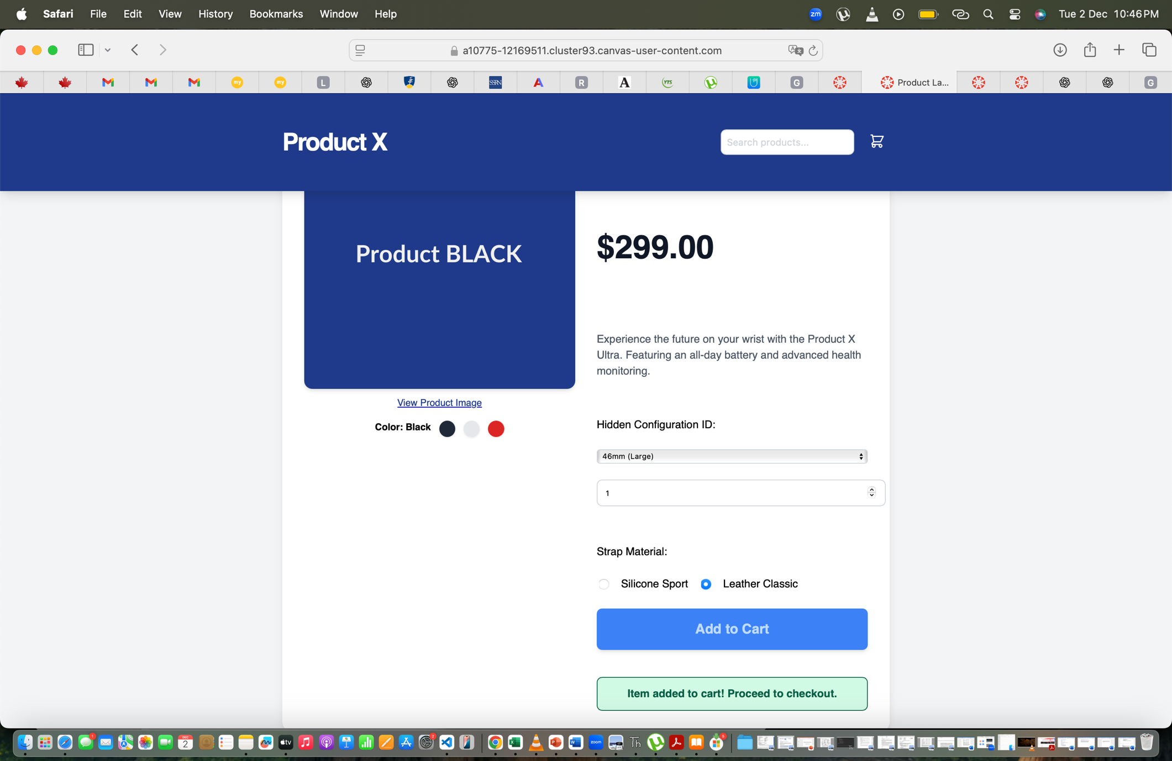 | Images without alt attributes prevent screen-reader users from understanding essential product information. | Add descriptive alt text such as: <img src='product-black.png' alt='Product X smartwatch, black edition'> | Broken WCAG level: WCAG 1.1.1 Non-text Content — Level A
Low color contrast | 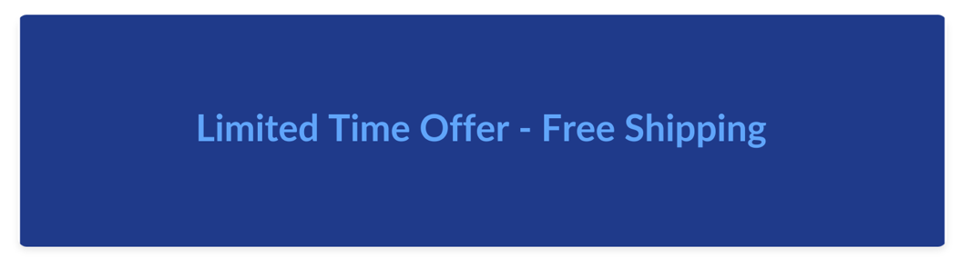 | Low contrast makes text unreadable for users with visual impairments. | Ensure contrast ratios meet 4.5:1 for normal text and 3:1 for large text. | Broken WCAG level: WCAG 1.4.3 Contrast (Minimum) — Level AA
Form elements missing labels |  | Unlabelled form controls cannot be understood by screen readers. | Add proper <label for='...'> elements linked to form controls. | Broken WCAG level: WCAG 3.3.2 Labels or Instructions — Level A
Incorrect heading structure | 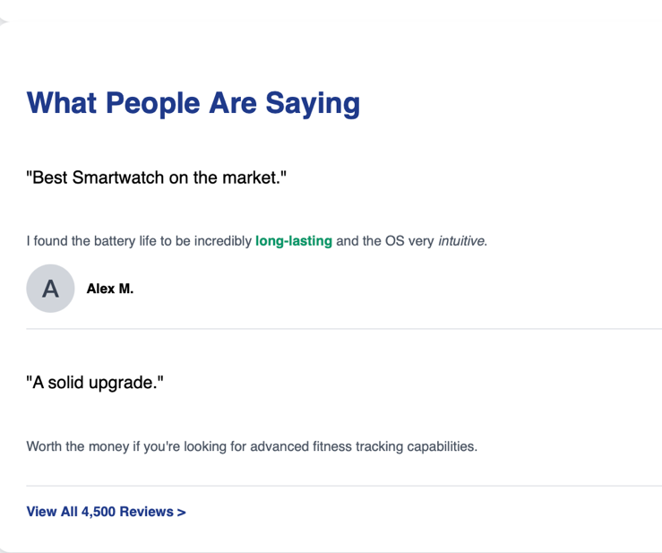 | Improper heading order makes navigation confusing for screen-reader users. | Use one h1 and follow proper hierarchy. | Broken WCAG level: WCAG 1.3.1 Info and Relationships — Level A
Data table missing header cells | 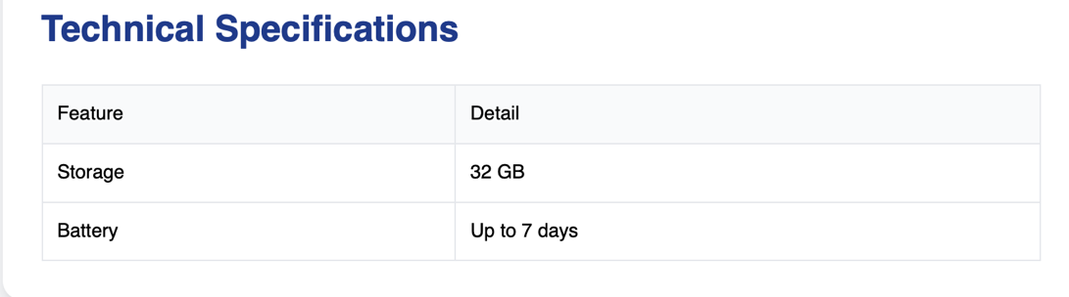 | Assistive tools can’t interpret rows/columns without <th> headers. | Add semantic headers like <th scope='col'>. | Broken WCAG level: WCAG 1.3.1 Info and Relationships — Level A
Buttons without accessible names | 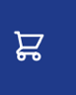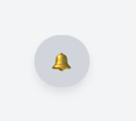 | Screen readers cannot interpret unlabelled buttons. | Ensure visible text or aria-label is provided. | Broken WCAG level: WCAG 4.1.2 Name, Role, Value — Level A

